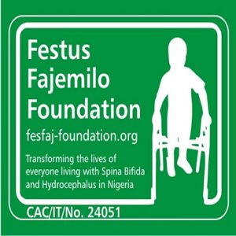
Photo
CONDITIONS FOR BEING A VOLUNTEER TO FESTUS FAJEMILO FOUNDATION (FFF)
(To be completed by all intending volunteers prior to joining FFF)
Preamble: Festus Fajemilo Foundation is a Non-Governmental Organization concerned with the plights of persons with hydrocephalus and spinal bifida in Nigeria with its head office situated in Lagos, Lagos State, Nigeria.
Mission: To provide information, services and advocacy to ensure that people with spinal bifida and hydrocephalus have equal access and right to good healthcare in Nigeria.
Vision: A Nigeria where everyone who has spinal bifida or hydrocephalus can access quality healthcare and support
Festus Fajemilo Foundation welcomes volunteers on the following terms and conditions:
- That the volunteer agrees with the mission and vision of the foundation.
- That the volunteer is aware of the core values of the Foundation which centers around respect for other cultures and no discrimination on religion, or sex, rights to equal opportunities and social protection for children with disability, and adherence to child protection policies.
- That the volunteer will at all time advance to goals of Festus Fajemilo Foundation and not use the name of the Foundation or any of its materials for personal benefits.
- That the volunteer agrees that his/her service to the Foundation shall be without any financial benefits in terms of allowance/wages/salaries.
- That the Foundations where applicable shall compensate the volunteers for his/her mileage expenses incurring such expenses and documentary approval is given.
- That the Foundation shall take legal action against any volunteer if it is found that such volunteer had used the name of the Foundation or any of its materials for personal benefit.
- I………………………………………………………….having read through the above terms and conditions agree to be a volunteer to Festus Fajemilo Foundation this ….…..day of …………………..… 201.…..

………………………… …………………………
On behalf of FFF Volunteer

